Example of visualisation of Forest vulnerability map wind & snow (pilot) in ArcGIS pro and QGIS

This text show one of many examples of how the Forest vulnerability map wind and snow (pilot) can be visualised in ArcGIS pro or Qgis.

ArcGISpro
Example of how to visualize vulnerability maps in ArcGIS pro:
- Import data into ArcGIS pro
- Go to symbology
- Chose stretch type “Standard deviation”
- Change the color scheme to something suitable
In figure 1 below you can see visualization derived from the result of the settings
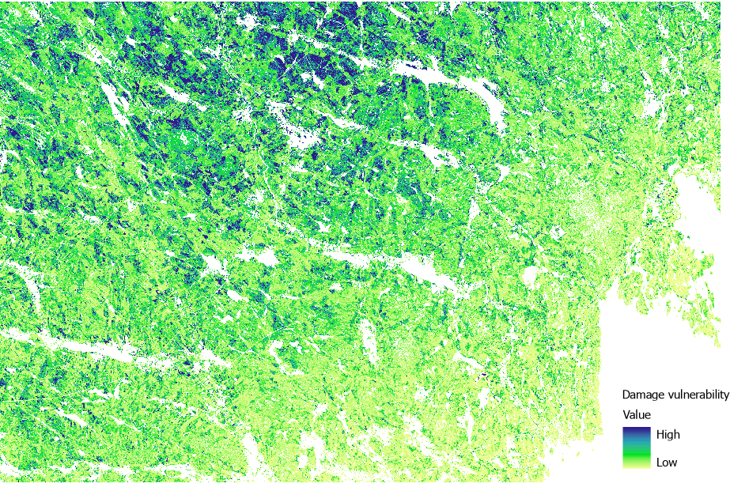
Figure 1: Example for visualizing damage vulnerability with mentioned settings in ArcGIS pro. Dark values indicates higher vulnerability for wind and snow damage.

QGIS
Example of how to visualize vulnerability maps in QGIS:
- Import data into QGIS
- Go layer propertiesà symbology.
- Chage the value setting to “Mean +/- standard deviation”
- Pick render type: to “singleband pseudocolor” (or a similar type) and a suitable color ramp to visualize the map in color.
In figure 2 below you can see visualization derived from the result of the settings
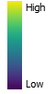
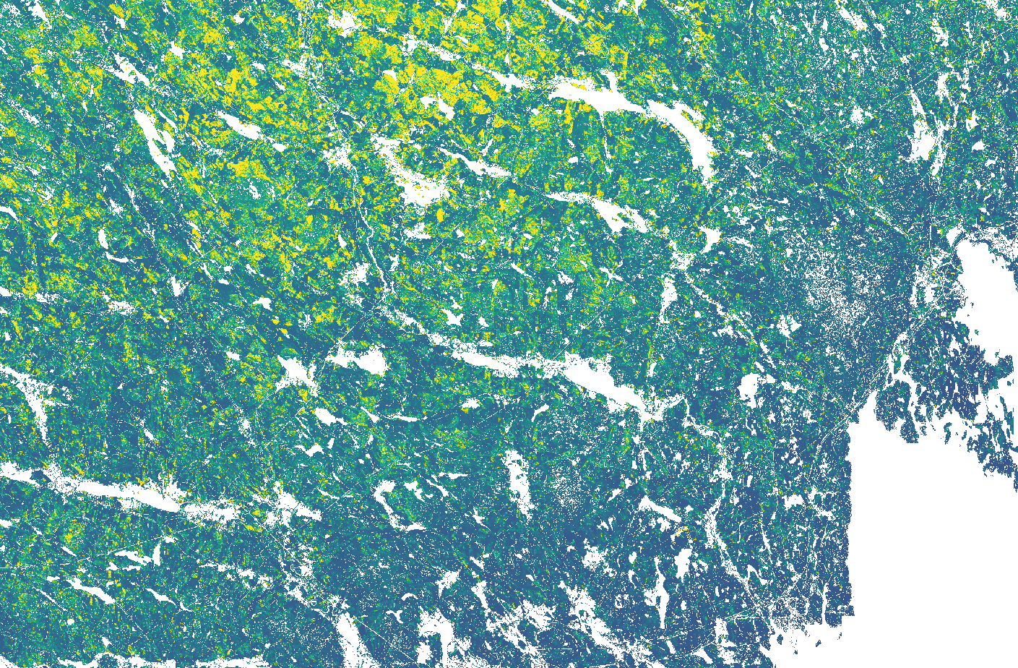
Figure 2: Example for visualizing damage vulnerability with mentioned settings in QGIS Dark values indicates lower vulnerability. Light values indicate higher vulnerability for wind and snow damage.

